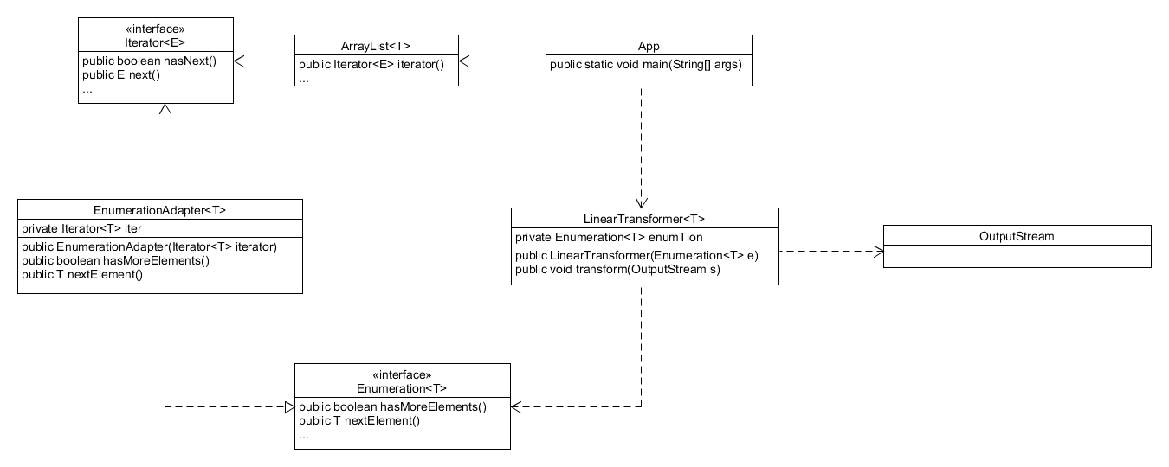1.

The App takes a generic ArrayList and passes the ArrayList’s iterator to the EnumerationAdapter. The adapter then sets its own Iterator to the one passed to it. The adapter then overrides Enumeration<T>’s methods using the Iterator. The adapter is then passed to the LinearTransformer.